Sammar Tahir
G00347526

Mobile Application Development

Contents
Project Overview: 2
Software support: 3
Objectives: 3
End user: 3
Other Ideas: 3


Project Overview:
This app if for people that love watching movies. The app shows the top 100 movies chosen by IMDB. Users can edit the movie list to their own liking if they don’t like the movies provided or think that one movie better than the other
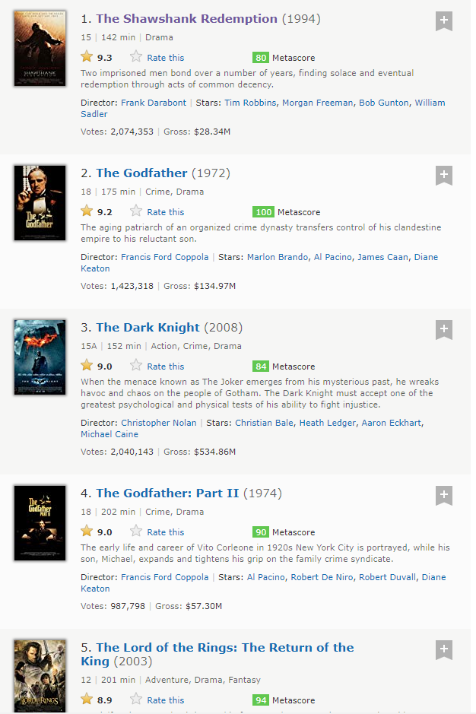

Movie lovers should be able to express themselves, what better way to do this than take a photo which can capture the moment. Take a picture and save it to your device so this moment lasts forever. I chose the do the pictures instead of writing reviews because young people prefer taking selfies. I got this idea from Instagram, where people can react to your stories using a selfie instead of a comment.

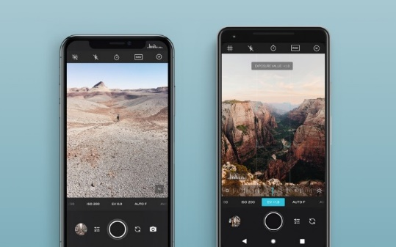
If you love watching movies, then you’ll defintly love making movies. Therefore, I allow the app user to make videos which they can edit later. This will be a basic functional camera to record video. Users should be able to choose photos or videos already on their device to open in the app to show to friends while discussing movies and their top 100 list.

Software support:
- Windows Application
- Android
- Local Storage

Objectives:
- View list items
- React to movies
- Create/Edit the movie list
- Record video using the app
- Open photos/videos on device using the app

End user:
Users can view the list which has over 50 movies to choose from. User will be able edit the top 100 list to their own liking, this will be saved locally. Users can access the camera and take photos or videos. Users can select a photo or video from the device and display it in app.

Other Ideas:
- GAA app
- Quiz app
- Car part finder app

